**Simple style transfer**

We’re using the following images as content image and style image.

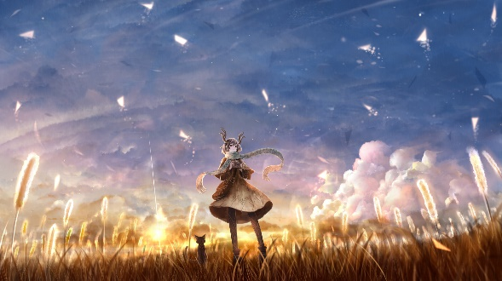 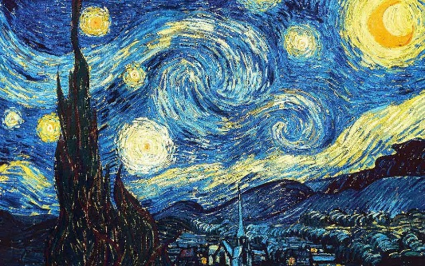

Using command line:

python network.py “images/inputs/content/test.jpg” “images/inputs/style/test.jpg” “images/output/test.jpg”

Model: VGG16

Layer: conv5_2

Iteration: 10

Content_weight: 0.025

Style_weight: 1

Pool_type: Average

Output (from iter1 to iter10):

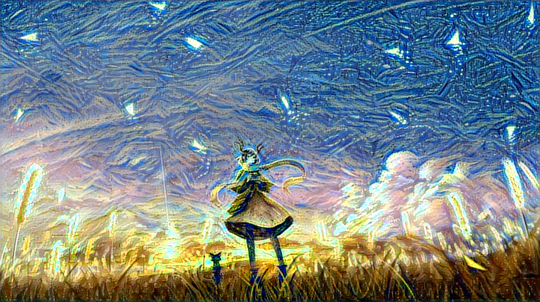

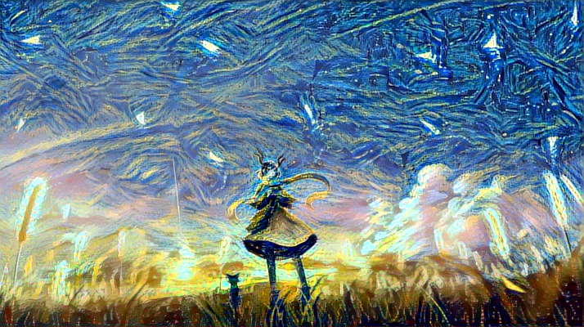

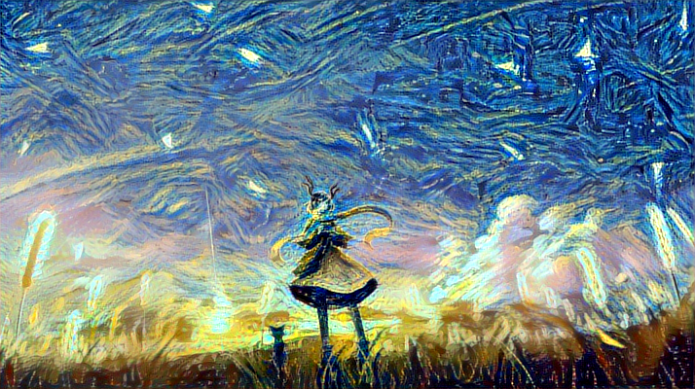

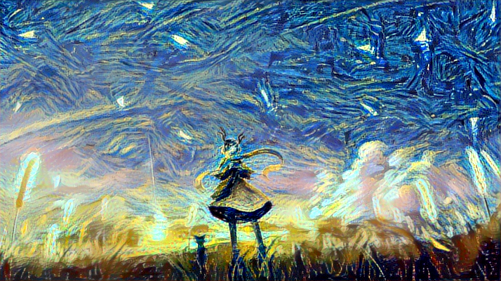

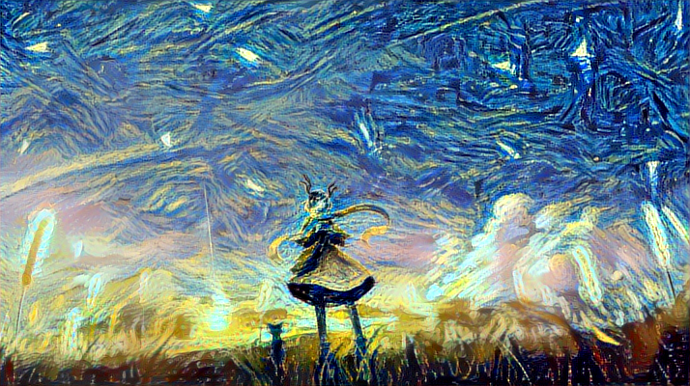

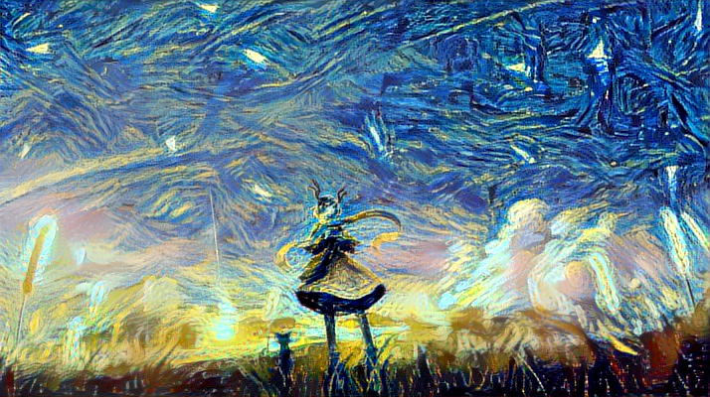

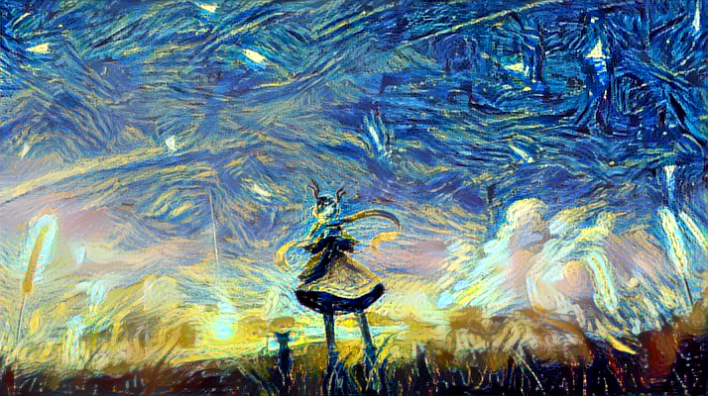

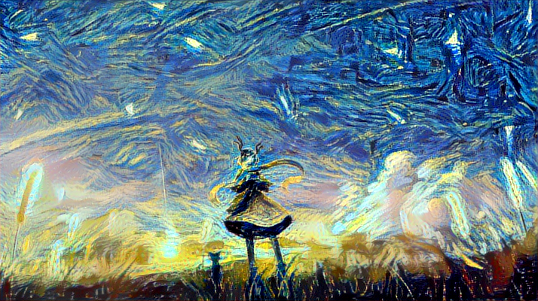

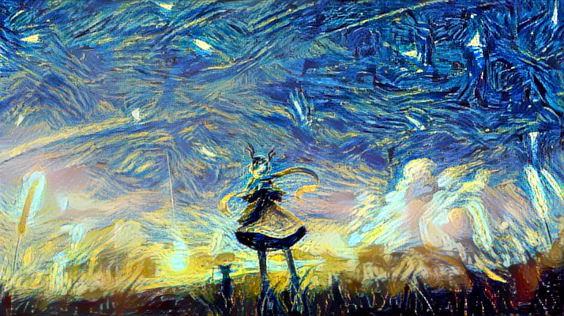

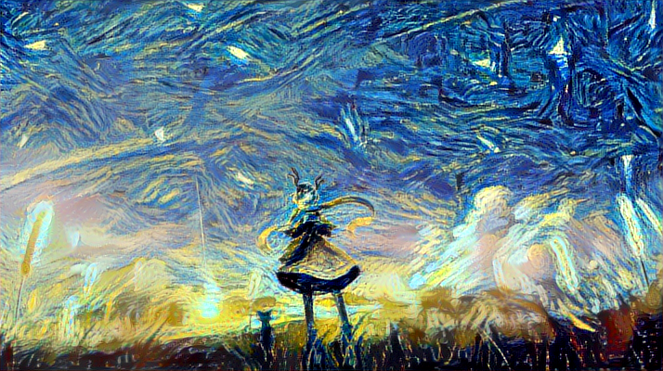

As we can clearly see, the original image is generated with the style of style image. From iteration 1 to iteration 10, the image is becoming smoother and stable.

Analysis:

* For image with more background to change, apply a larger style_weight and smaller content_weight. Otherwise apply larger content_weight.

Example:

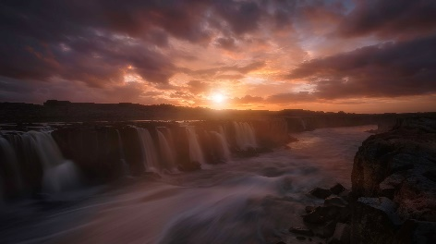 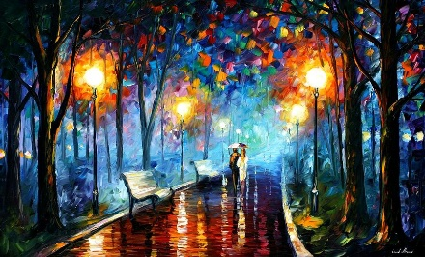

Style=1, Content=1000

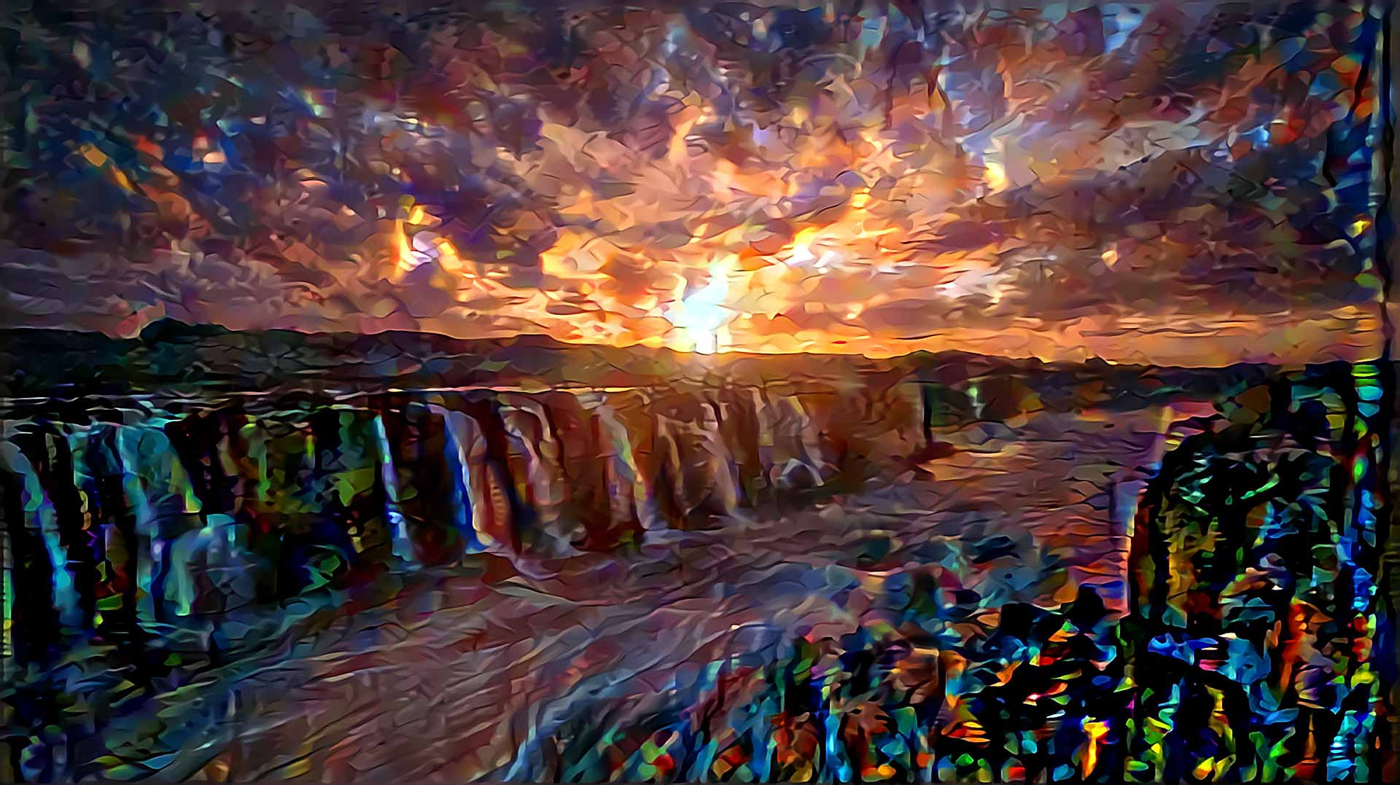

Style=1, Content=1

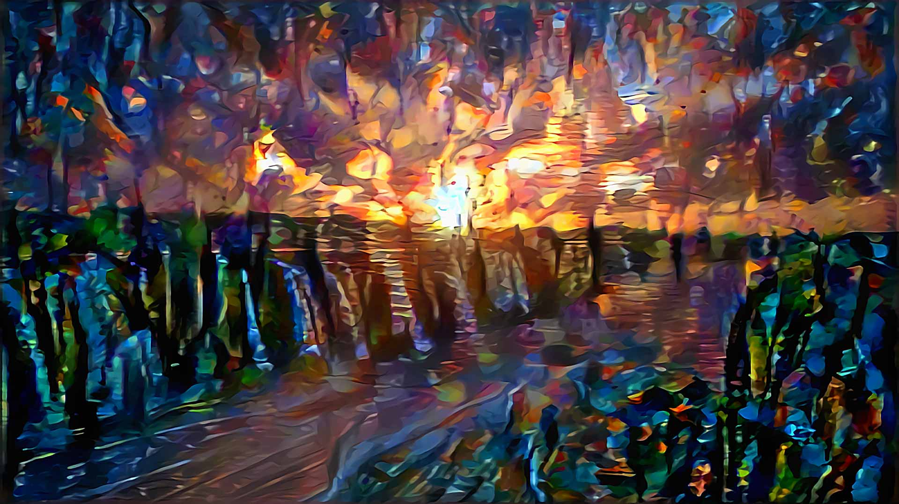

Style=1000, Content=1

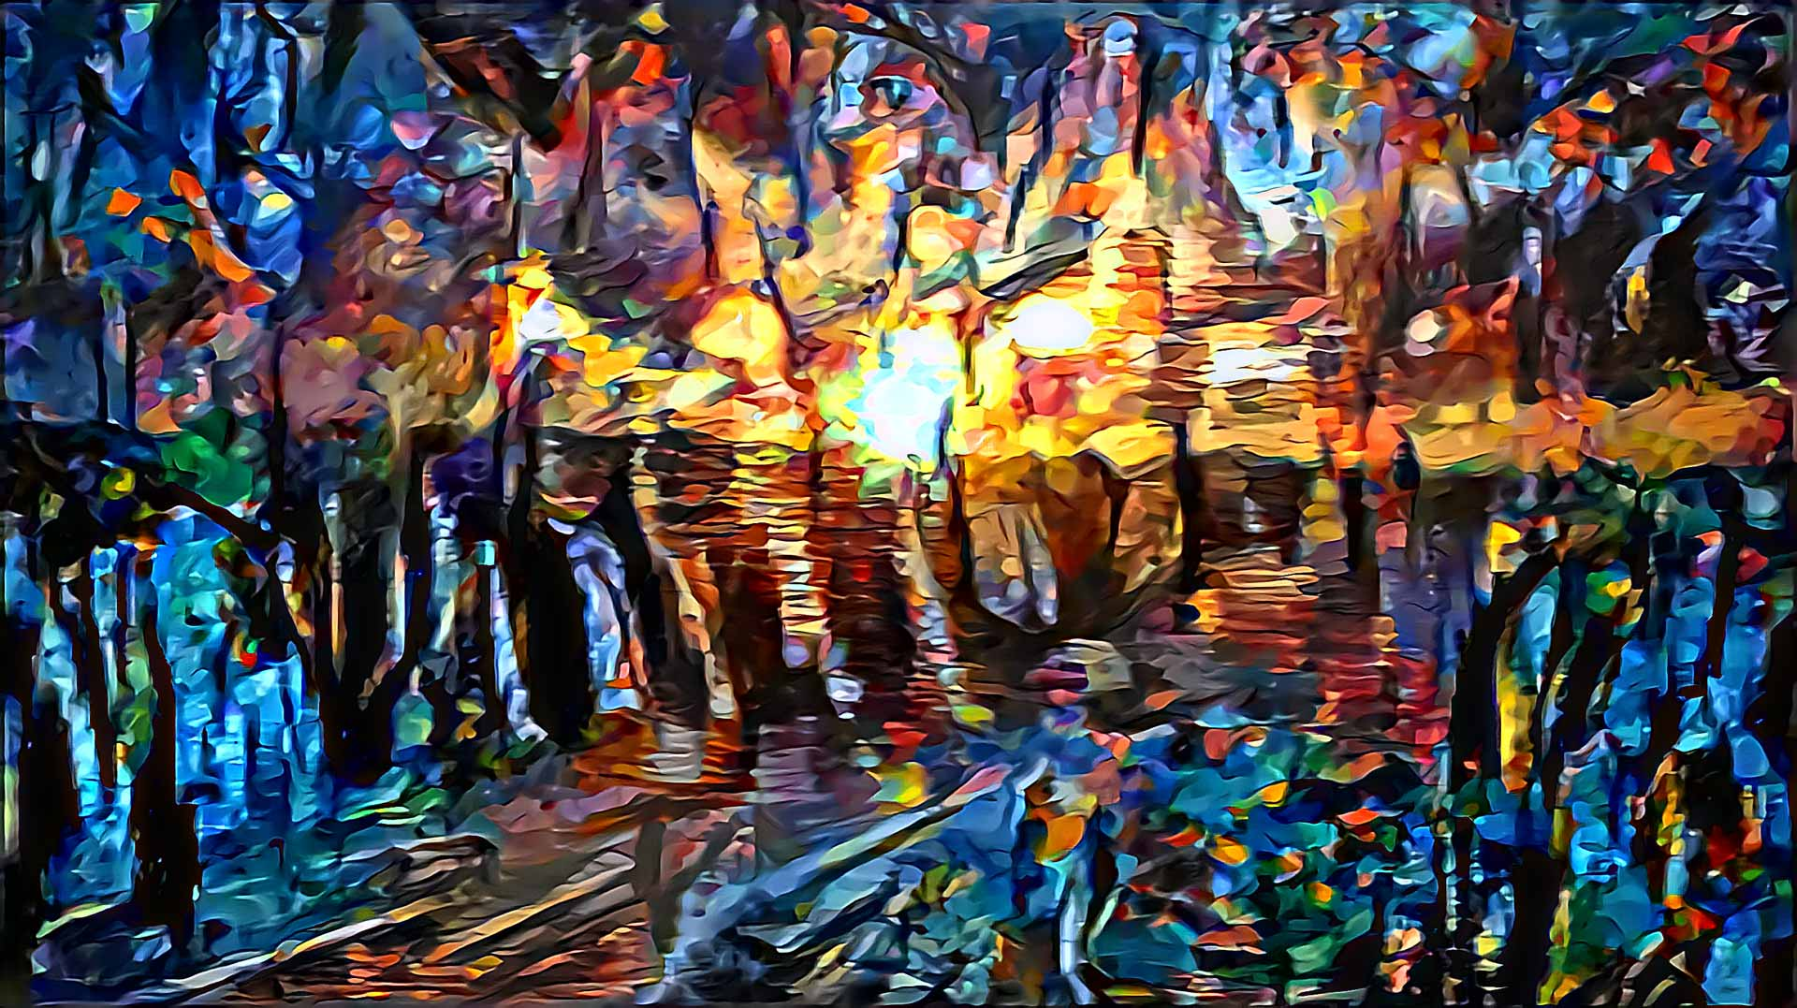

* For smoother image, apply average pooling. Mostly max pooling show better results.
* For better generated image, add iteration numbers. On local computer, each iteration takes about 260-300 seconds.
* For 400*400 scale image, can’t see much difference between using VGG16 and VGG19. VGG19 takes a little more time.

**Masked style transfer**

For many images, we may not want to change all content to given style. We may want to keep some regions of the original image and change the rest part. Here we use mask to achieve the goal. Mask is a black-white(0-1) grey-scale image generated from the original image. Black part is the region we don’t want to change, while the white part is where we want to change. Judged by RGB.

Mask:

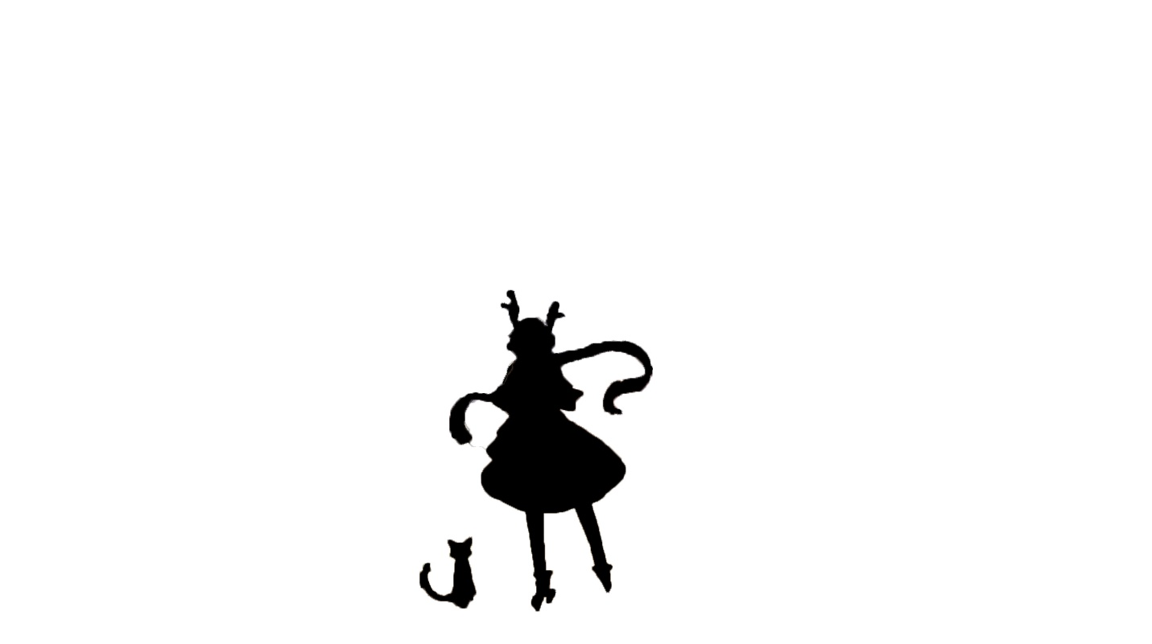

Output:

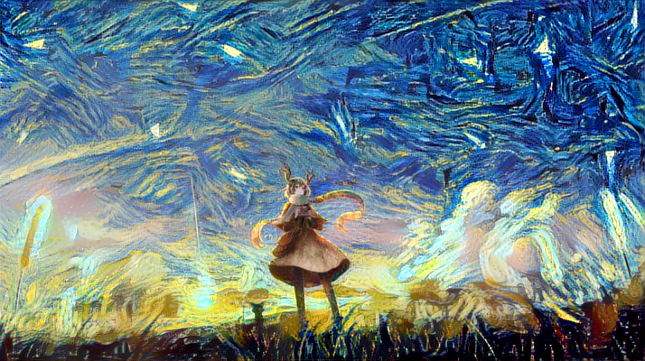

Compare without mask:



Analysis:

* Masked region is not generated, the rest is the same as previous image.
* Advantage:
  + Obviously seems better when only the background needs to be generated.
  + Could apply larger content_weight and less style_weight to make image smoother.
* Disadvantage:
  + Mask image need to be done by people. Using PS to generate mask image as needed.

**Transfer with Color Preservation**

Sometimes we may want to keep the original color of the image. Here we use YCbCr mode to achieve the goal.

Input:

content_image:

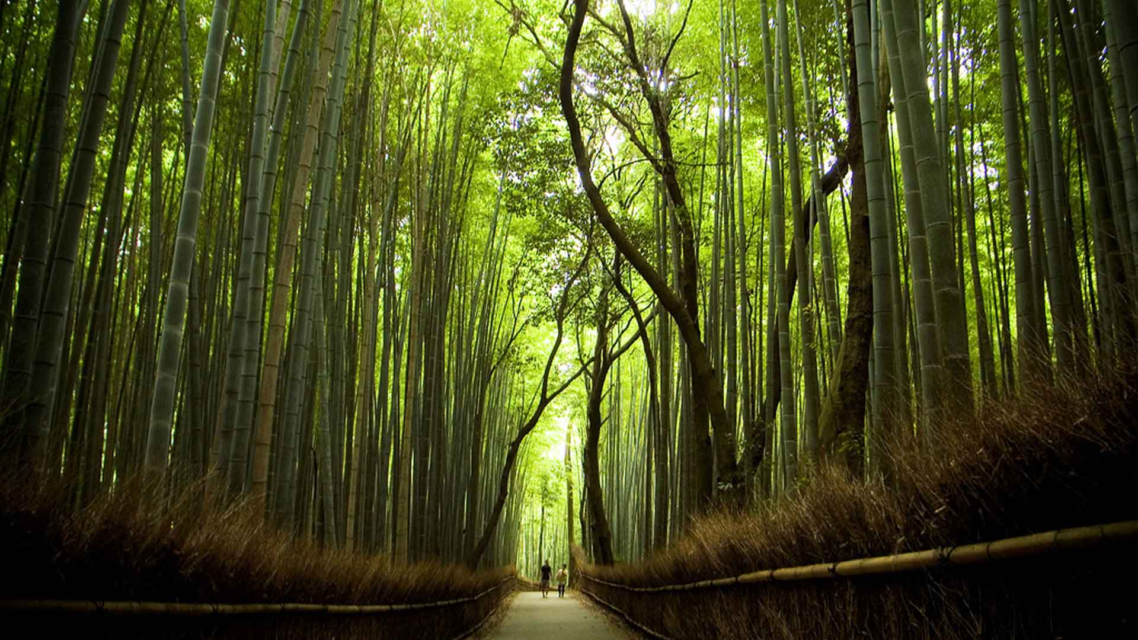

style_image:

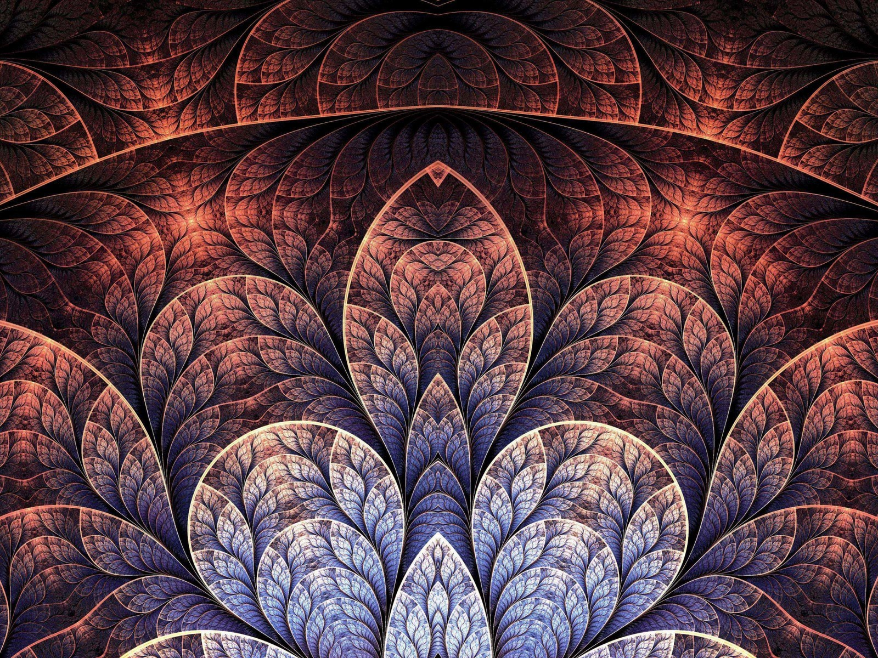

Output:

without color_preservation:

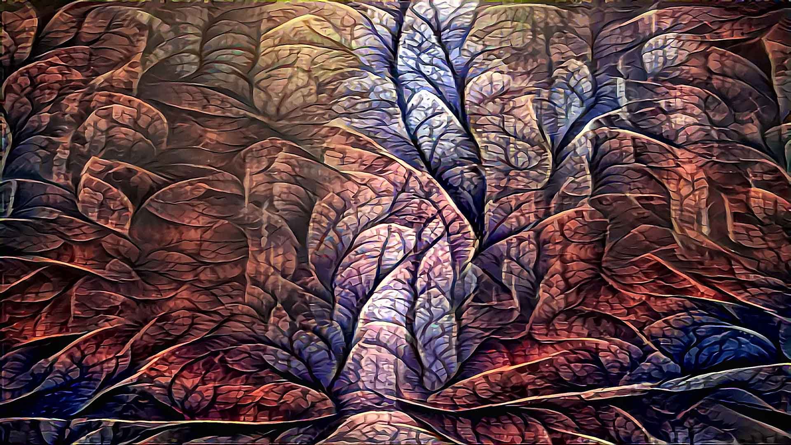

with color_preservation:

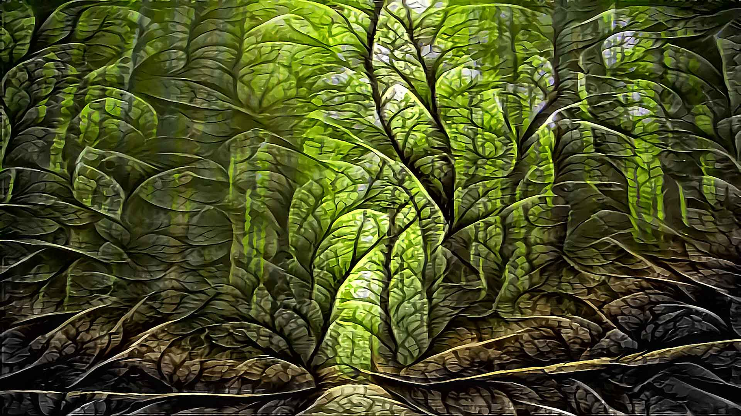

Generates the same style as the output without color_preservation. Preserved the color we want to keep. Better fit in more style images.

**Conclusion**

Achievements:

* Achieved style transfer using VGG model in keras. Generates satisfying outputs.
* Chose appropriate parameters to generate better output.
* Using mask method and color preservation method to better fit business usage.
* Created simple interface to better generate command line arguments.

Future work:

* Add rescaling method to images like bilinear, bicubic to generate more images other than 224*224 to get better quality. Denoise method should also be concerned.
* Instead of using conv4_2 as discussed in many papers, we chose conv5_2 after test for better output in our test cases. Still need more test on which layer suits which style. And since we choose conv5_2, the ratio of content_weight : style_weight should be decided really carefully. Around 1:0.05 is recommended after test.
* Now we’re only using original loss. Trying using other scaling of the loss and see how it’ll change. Like loss = 1 / (2 * sqrt(channels) * sqrt(width * height)).
* Try to improve the speed of the model.
* I have an idea of making it live with webcam. Can’t be done cause it need a really good GPU.